SPM satellites movement test program test report

Function Points:

1. It allow testers to add information into the EXCEL shit autoly. Each satellite has three datas: semiminor, semimajor, true anomaly. But the tester can also add the data in the shit by hand. What we should pay attention is that the local information of satellite is all for now.
2. The “check” button will check all of the satellites in the shit to find out whether there would be any satellite will have a collision in five days. If there would be none collision in five days, the program will give a output text: everything is ok!
3. When there would be any collision in five days, the program will give a warning that which satellite would have a collision in five days. It will give the code number of those satellites.

Test Result:

1. function1:

step1:

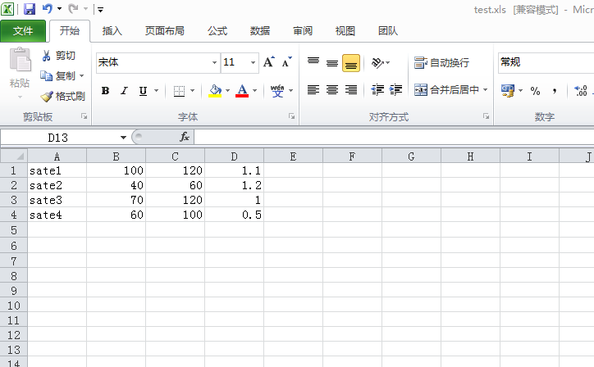

Step2:

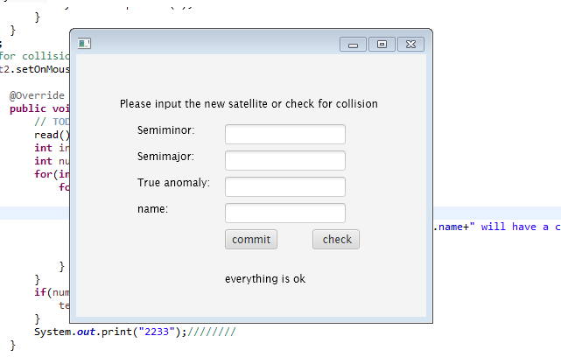

Step3:

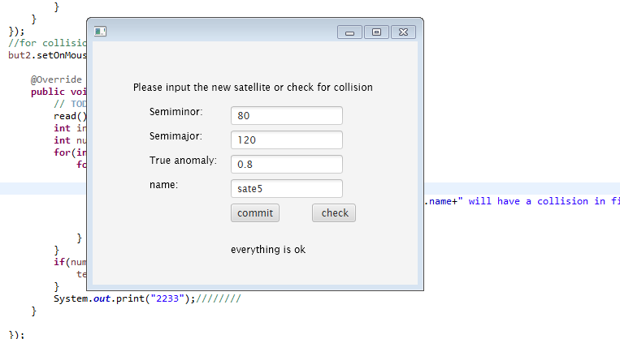

Step4:

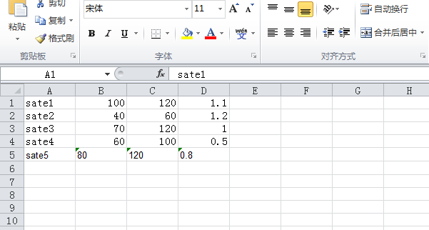

1. function2:

step1:

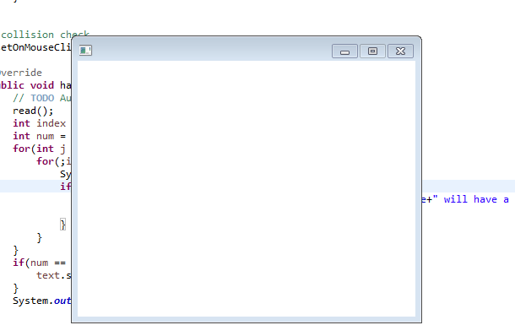

Step2:

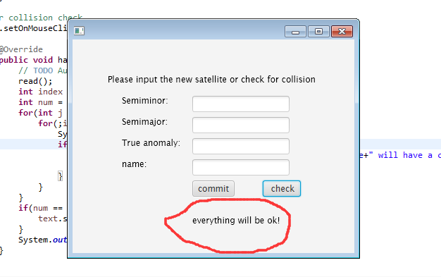

1. function1:

Step1:

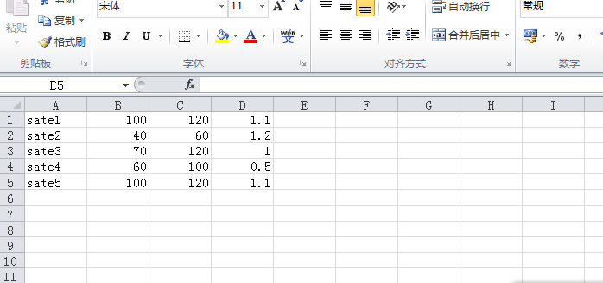

step2:



Step3:

